

**MESA DAY 2024-2025**

SCIENCE JOURNAL REQUIREMENT

BIO BREAKTHROUGH

**HIGH SCHOOL TEMPLATE**

NAMES:____________________________________________

*(team member names)*

SCHOOL:___________________________________________

CENTER: ___________________________________________

LEVEL (circle one): 9/10th gr 11/12th gr

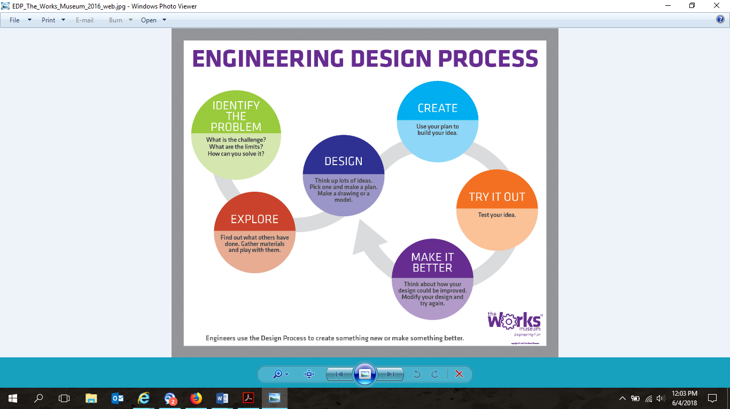

1. **USING TWO TO THREE SENTENCES,** **ANSWER THE FOLLOWING QUESTIONS:**

*What is transcription?*

|  |
| --- |

*What is Translation?*

|  |
| --- |

*What are the steps of transcription?*

|  |
| --- |

1. **USING TWO TO THREE SENTENCES,** **ANSWER THE FOLLOWING QUESTIONS:**

*What is a CRISPR Cas9?*

|  |
| --- |

*What is a monogenic disease?*

|  |
| --- |

*How does scissoring work in a Cas9 protein?*

|  |
| --- |

1. **DEFINE THE FOLLOWING SCIENTIFIC TERMS IN TWO TO THREE SENTENCES:**

*Gene editing*

|  |
| --- |

*Guide RNA (gRNA)*

|  |
| --- |

*Cas9 Protein*

|  |
| --- |

1. **SKETCH OF Cas9 Protein WITH LABELED PARTS (SKETCHES CAN BE HAND DRAWN OR COMPUTER GENERATED [MUST BE ORIGINAL WORK]):**

Cas9 protein gRNA PAM sequence

Target DNA Repair template

|  |
| --- |

1. **DESCRIBE IN FOUR TO FIVE SENTENCES HOW CRISPR CAN BE USED TO IMPACT MARGINALIZED COMMUNITIES IMPACTED BY A SPECIFIC DISEASE/DISORDER.**

|  |
| --- |